Program:
A program is a prepared sequence of instructions to accomplish a defined task.
The C compiler
1. Translates each source file into an object file.
2. The compiler then links the individual object files with the necessary libraries to produce an executable module.
3. When a program is run or executed, the operating system copies the executable module into a program image in main memory
Multistage Processing of a User Program
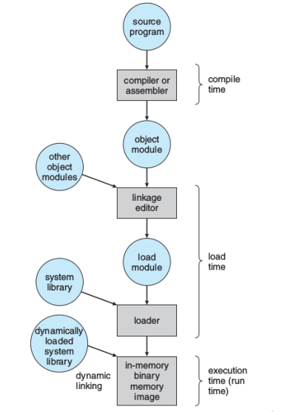

Layout of a Program Image in Main Memory
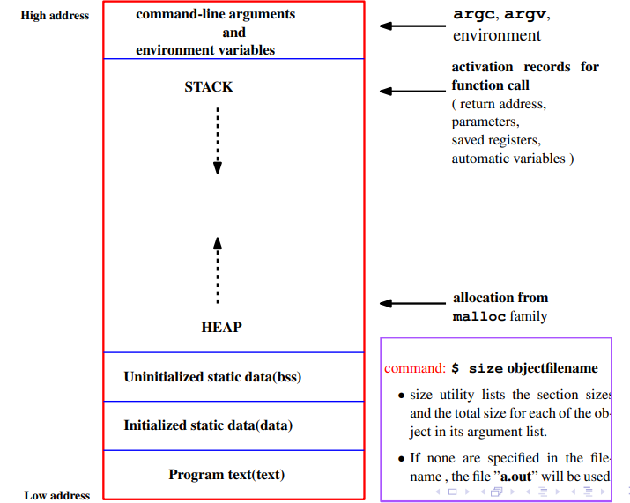
Process
process is an instance of a program that is executing (A program which is dispatched from ready state and are scheduled for execution)
When does program become process?
☞The operating system reads the program into memory.
☞ The allocation of memory for the program image is not enough to make the program a process.
☞ The process must have an ID (the process ID) so that the operating system can distinguish among individual processes. The process state indicates the execution status of an individual process.
☞ The operating system keeps track of the process IDs and corresponding process states and uses the information to allocate and manage resources for the system.
☞ The operating system also manages the memory occupied by the processes and the memory available for allocation.
☞ When the operating system has added the appropriate information in the kernel data structures and has allocated the necessary resources to run the program code, the program has become a process.
☞ A process has an address space (memory it can access) and at least one flow of control called a thread.
☞ The variables of a process can either remain in existence for the life of the process (static storage) or be automatically allocated when execution enters a block and deallocated when execution leaves the block (automatic storage)
Process State
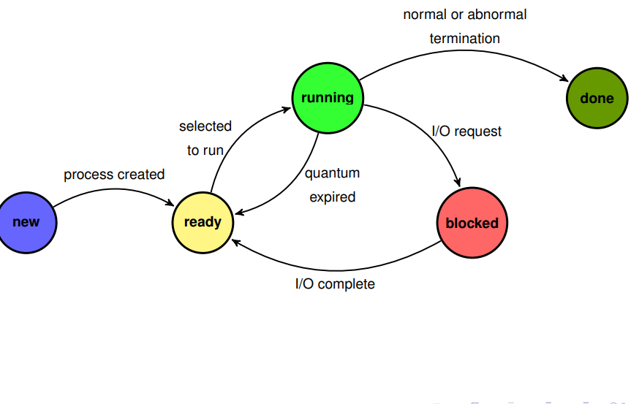
Thread :
A thread is a single sequence stream within a process. Threads are also called lightweight processes as they possess some of the properties of processes. A thread is a lightweight subpart of that process that performs a specific task.
Example:
Operating System
│
└── Chrome Main Process (chrome.exe)
├── Renderer Process (for Tab 1)
│ ├── Main/UI Thread
│ ├── Compositor Thread
│ └── IO Thread
│
├── Renderer Process (for Tab 2)
│ ├── Main/UI Thread
│ ├── Compositor Thread
│ └── IO Thread
│
├── GPU Process
│ └── Rendering Threads
│
├── Network Process
│ └── Download and Socket Threads
│
└── Extension Process
└── Background Script Threads

Tracking ongoing processes
1. ps (Process status) can be used to see/list all the running processes.
For single-process information, ps along with process id is used
-a: Shows information about all users
-x: Shows information about processes without terminals
-u: Shows additional information
-f: Displays full information For a running program
ps -al : Shows information about all process
ps -ef: Full-format listing
ps aux: BSD-style detailed view

Outputs
Pidof finds the process id’s (pid Fields described by ps are described as:
● UID: User ID that this process belongs to (the person running it)
● PID: Process ID
● PPID: Parent process ID (the ID of the process that started it)
● C: CPU utilization of process
● STIME: Process start time
● TTY: Terminal type associated with the process
● TIME: CPU time is taken by the process
● CMD: The command that started this process
● VSZ: Total amount of virtual memory used by the process
● RSS: Actual physical memory (RAM) currently occupied by the process (in kilobytes). This excludes memory swapped out to disk.

2. Kill: Used to stop a process
Syntax:: $ kill process-id Example:: $ kill 4578
Process Identification
☞UNIX identifies processes by a unique integral value called the process ID.
☞ Each process also has a parent process ID, which is initially the process ID of the process that created it.
☞ If this parent process terminates, the process is adopted by a system process so that the parent process ID always identifies a valid process.
getpid and getppid Function
The getpid function returns the process ID .
☞ The getppid function returns the parent process ID.
☞ The pid_t is an unsigned integer type that represents a process ID.
#include <unistd.h>
pid_t getpid(void);
pid_t getppid(void);
Neither the getpid nor the getppid functions can return an
error.

Example
#include<stdio.h>
#include<unistd.h>
int main (void)
{
printf("I am process %ld\n", (long)getpid());
printf("My parent is %ld\n", (long)getppid());
return 0;
}

UNIX Process Creation and fork
✍ A process can create a new process by calling fork.
✍ The calling process becomes the parent, and the created process is
called the child.
✍ The fork function copies the parent’s memory image so that the new
process receives a copy of the address space of the parent.
✍ Both processes continue at the instruction after the fork statement (executing in their respective memory images).
✍ fork() prototype
#include <unistd.h>
pid_t fork(void);

✍ fork() function returns
(1) returns 0 to the child
(2) returns the child’s process ID to the parent.
(3) When fork fails, it returns -1
Note:: The fork function return value is the critical characteristic that allows the parent and the child to distinguish themselves and to execute different code.
Example:
#include <stdio.h>
#include <unistd.h>

int main() {
pid_t pid = fork();

if (pid > 0)
printf("Parent Process: PID = %d, Child PID = %d\n", getpid(), pid);
else if (pid == 0)
printf("Child Process: PID = %d, Parent PID = %d\n", getpid(), getppid());
else
printf("Fork failed!\n");
return 0;
}
Example 1:
#include <stdio.h>
#include <unistd.h>
int main() {
printf("Before fork\n");
fork();
printf("After fork\n");
return 0;
}
o/p: Before fork
After fork
After fork
Explanation
P #before fork
(fork)

C P #After fork

Or
Parent process
#include <stdio.h>
#include <unistd.h>
int main() {
printf("Before fork\n");
fork();
printf("After fork\n");
return 0;
}

Child process
#include <stdio.h>
#include <unistd.h>
int main() {
printf("After fork\n");
return 0;
}

Example2:
#include <stdio.h>
#include <unistd.h>
int main() {
fork(); // 1st fork
fork(); // 2nd fork
printf("Process: PID = %d, PPID = %d\n", getpid(), getppid());
return 0;
}
Explanation:
Parent
Child 0
#include <stdio.h>
#include <unistd.h>
int main() {
fork(); // 1st fork
fork(); // 2nd fork
printf("Process: PID = %d, PPID = %d\n", getpid(), getppid());
return 0;
}

Child 2
#include <stdio.h>
#include <unistd.h>
int main() {
printf("Process: PID = %d, PPID = %d\n", getpid(), getppid());
return 0;
}

#include <stdio.h>
#include <unistd.h>
int main() {
fork(); // 2nd fork
printf("Process: PID = %d, PPID = %d\n", getpid(), getppid());
return 0;
}

Child 1
#include <stdio.h>
#include <unistd.h>
int main() {
printf("Process: PID = %d, PPID = %d\n", getpid(), getppid());
return 0;
}

Process Tree Visualization
Parent (P0)
├── Child1 (P1)
│ └── Grandchild (P3)
└── Child2 (P2)
or

P
C1 P
C2 C1 C3 P

Remember: Total = 2ⁿ processes (for n successful forks).
Example:
#include <stdio.h>
#include <unistd.h>
int main() {
fork();
if (fork())
fork();
printf("PID=%d\n", getpid());
return 0;
}

o/p: PID=313
PID=314
PID=311
PID=312
PID=315
PID=316

Total 6 processes

Child 2: if (0)
To Understand
PF()
Child 1

printf("PID=%d\n", getpid());
return 0;
}

if (fork())
fork();
printf("PID=%d\n", getpid());
return 0;
}

Child 3
Child 1
printf()
return 0;
}

if (1)
fork();
printf()
return 0;
}

Parent

PF()
#include <stdio.h>
#include <unistd.h>
int main() {
fork();
if (fork())
fork();
printf("PID=%d\n", getpid());
return 0;
}

PF()

Parent

if (1)
fork();
printf("PID=%d\n", getpid());
return 0;
}

printf("PID=%d\n", getpid());
return 0;
}

Child 5
printf("PID=%d\n", getpid());
return 0;
}

Child 4

Process Tree:
Child 2:
If(0)
Child 1

printf("PID=%d\n", getpid());
return 0;
}

if (fork())
fork();
printf("PID=%d\n", getpid());
return 0;
}

Child 3
printf()
return 0;
}

If(1) then inner fork() gets called and this creates child 3
Parent Process

#include <stdio.h>
#include <unistd.h>
int main() {
fork();
if (fork())
fork();
printf("PID=%d\n", getpid());
return 0;
}

Child 4:
If(0)
printf("PID=%d\n", getpid());
return 0;
}

Child 5
If(1) then inner fork() gets called and this creates child 5
printf()
return 0;
}

• For A && B:
👉 If A is false (0), then B is not evaluated, because the whole expression can never be true.
• For A || B:
👉 If A is true (non-zero), then B is not evaluated, because the whole expression is already true.

1||x = 1
0||x=x

Example
#include <stdio.h>
#include <unistd.h>
int main() {
fork();
if (fork()||fork())
fork();
printf("PID=%d\n", getpid());
return 0;
}
o/p:
PID=322
PID=323
PID=324
PID=325
PID=327
PID=326
PID=329
Child 3
int main() {
printf();}

PID=328
PF()
PID=330
Child 4
PF()
Child 1
PID=331
int main() {
if (0||0)
printf();}

PF()
int main() {
if (1||fork())
fork();
printf();}

Child 2
Child 1
Child 2
int main() {
if (0||1)
fork();
printf();}

int main() {
if (0||f)
fork();
printf();}

Parent Process
int main() {
fork();
if (fork()||fork())
fork();
printf(); return 0;}

int main() {
if (fork()||fork())
fork();
printf();
return 0;}

Child 5
PF()
PF()
int main() {
printf();}

Parent
Child 2
PF()
int main() {
printf();}

int main() {
if (1||fork())
fork();
printf();}

Child 8
PF()
int main() {
if (0||f)
fork();
printf();}

Child 6

Child 6
Child 7
PF()
Child 9
int main() {
if (0||0)
fork();
printf();}

int main() {
if (0||1)
fork();
printf();}

int main() {
printf();}

PF()
PF()
0&&x = 0
1&&x =x
Example
#include <stdio.h>
#include <unistd.h>
int main() {
fork();
if (fork() && fork())
fork();
printf("PID=%d\n", getpid());
return 0;
}
o/p:
PID=350
PID=351
PID=348
PID=349
PID=352
PID=353
PID=355
PID=354

Child 2
PF()
PF()
int main() {
if (0&&fork())
fork();
printf(); return 0;}

Child 3
int main() {
if (1&&0)
fork();
printf(); return 0;}

Parent Process
int main() {
if (fork()&&fork())
fork();
printf(); return 0;}

int main() {
fork();
if (fork()&&fork())
fork();
printf(); return 0;}

PF()
int main() {
if (1&&1)
fork();
printf(); return 0;}

Child 1
Child 1
PF()
Child 5
int main() {printf(); return 0;}

int main() {
if (0&&fork())
fork();
printf(); return 0;}

Child 4
PF()

int main() {
if (1&&0)
fork();
printf(); return 0;}

int main() {
if (1&&fork())
fork();
printf(); return 0;}

Parent
PF()

Child 6
PF()
Child 7
int main() {
if (1&&1)
fork();
printf(); return 0;}

parent
PF()
int main() {printf(); return 0;}

Example:
#include <stdio.h>
#include <unistd.h>
int main() {
for (int i = 0; i < 3; i++)
fork();
printf("Hi");
return 0;
}

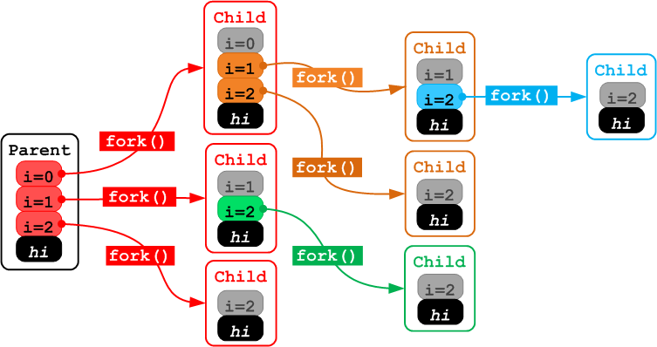

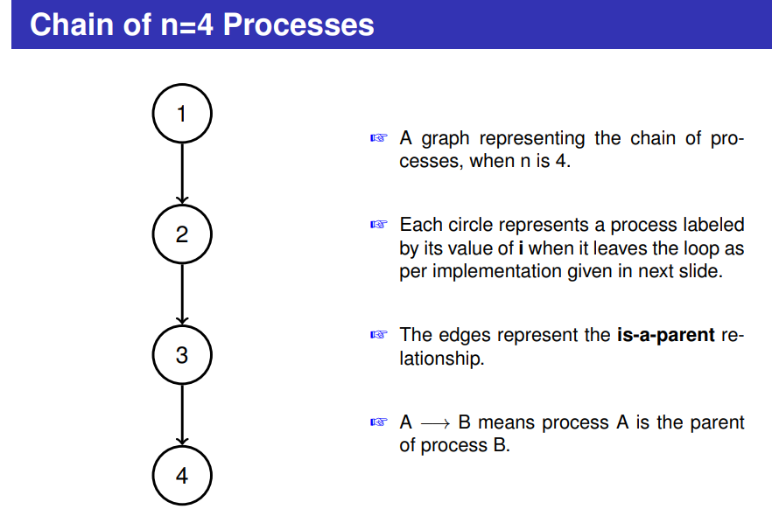
Example
#include <stdio.h>
#include <stdlib.h>
#include <unistd.h>
int main (int argc, char *argv[]) {
pid_t childpid = 0;
int i, n;
if (argc != 2){/* check for valid number of
command-line arguments */
fprintf(stderr, "Usage: %s processes\n", argv[0]);
return 1;
}
n = atoi(argv[1]);
for (i = 1; i < n; i++)
if (childpid=fork())
break;
fprintf(stderr, "i:%d process ID:%ld parent ID:%ld child ID:%ld\n", i, (long)getpid(), (long)getppid(), (long)childpid);
return 0;
}
☞ Creates a chain of n processes by calling fork in a loop.
☞ On each iteration of the loop, the parent process has a nonzero childpid and hence breaks out of the loop.
☞ The child process has a zero value of childpid and becomes a parent in the next loop iteration.
☞ In case of an error, fork returns -1 and the calling process breaks out of the loop.
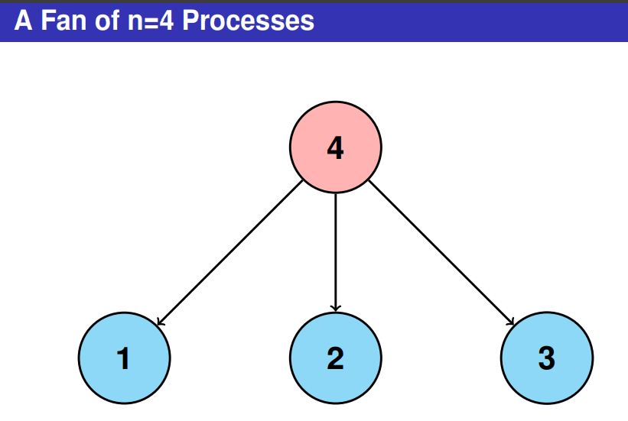
#include <stdio.h>
#include <stdlib.h>
#include <unistd.h>
int main (int argc, char *argv[]) {
pid_t childpid = 0;
int i, n;
if (argc != 2){
/* check for valid number of command-line arguments */
fprintf(stderr, "Usage: %s processes\n", argv[0]);
return 1;
}
n = atoi(argv[1]);
for (i = 1; i < n; i++)
if ((childpid = fork()) <= 0)
break;
fprintf(stderr, "i:%d process ID:%ld parent ID:%ld child ID:%ld\n",i, (long)getpid(), (long)getppid(), (long)childpid);
sleep(1000);
return 0;
}
(pstree –p 510)
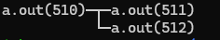
Example 2
#include <stdio.h>
#include <stdlib.h>
#include <unistd.h>
int main (int argc, char *argv[]) {
pid_t childpid = 0;
int i, n;
if (argc != 2){
/* check for valid number of command-line arguments */
fprintf(stderr, "Usage: %s processes\n", argv[0]);
return 1;
}
n = atoi(argv[1]);
for (i = 1; i < n; i++)
if ((childpid = fork()) ==-1)
break;
fprintf(stderr, "i:%d process ID:%ld parent ID:%ld child ID:%ld\n",i, (long)getpid(), (long)getppid(), (long)childpid);
sleep(1000);
return 0;
}
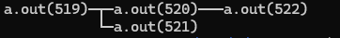
Remember
- Child process doesn’t inherits
its parent’s memory locks.
inherit semaphore adjustments from its parent
inherit record locks from its parent.
inherit timers from its parent
outstanding asynchronous I/O operations from its parent, nor does it inherit any asynchronous I/O contexts from its parent.
- Process resource utilizations and CPU time counters are reset to zero in the child.
- The child does not receive a signal when its parent terminates.
- The termination signal of the child is always SIGCHLD.
- The port access permission bits set by ioperm (ioperm - set port input/output permissions) are not inherited by the child
- The child process is created with a single thread-the one that called fork(). The entire virtual address space of the parent is replicated in the child, including the states of mutexes, condition variables, and other pthreads objects.

- The child inherits copies of the parent’s set of open file descriptors. Each file descriptor in the child refers to the same open file description as the corresponding file descriptor in the parent.

- The child inherits copies of the parent’s set of open message queue descriptors.

- The child inherits copies of the parent’s set of open directory streams.

What Does the Parent Do While the Child Executes
It can do two things:
✍ Wait to gather the child’s exit status.
✍ Continue execution without waiting for the child( and pick up the exit status later, if at all)
Two system calls invoked in waiting wait() and waitpid()
Process Termination
When a process terminates, the operating system deallocates the process resources
The operating system records the process status and resource usage, notifying the parent in response to a wait function.
In UNIX, a process does not completely release its resources after termination until the parent waits for it.
✍ If its parent is not waiting when the process terminates, the process becomes a zombie.
✍ A zombie is an inactive process whose resources are deleted later when its parent waits for it.
✍ A normal termination occurs under the following conditions;
✍ return from main
✍ Implicit return from main (the main function falls off the end)
✍ Call to exit, _Exit or _exit
ZOMBIE
✍ If the child dies first, the kernel empties the process address space but retains the process table entry. The child is said to be in a zombie state.
✍ The zombie is actually not a process at all, so canot be killed.
✍ The only reason for a child to memain in the zombie state is the hope that the parent may eventually call wait or waitpid to pickup the exit status and clear the process table slot.
✍ Type man ps to read process state information and locate the state zombie
A zombie is a process which has terminated but its entry still exists in the process table until the parent terminates normally or calls wait().
This happens because the child is no longer active but its exit code needs to be stored in case the parent subsequently calls wait.
Code:
#include<stdio.h>
#include<unistd.h>
int main()
{
pid_t childpid;
childpid=fork();
if(childpid==-1){
printf("fork error\n");
return 1;
}
else if (childpid==0){
printf(" I am child my process ID=%ld\n",(long)getpid());
exit(0);
}
else{
printf("I am parent My PID=%ld\n",(long)getpid());
sleep(100);
wait(NULL);
exit(0);
}
}

✍ On the other terminal run the command
(ps -la | grep CMD) ; (ps -la | grep a.out)
✍ Look into the line that contains defaunct. It is the Zombie with process state code Z
✍ After the program terminate, again type the command ps -la. Is the ZOMBIE exit or not? If not process terminate.
✍ For more man ps to read process state information under the heading PROCESS STATE CODES.
ORPHAN
✍ When the parent dies first, the child becomes an orphan since the parent is not just there to pickup the child’s exit status.
✍ The kernel clears the process table slot of the parent, but before doing so, it checks whether there are any process spawned by the parent that are still alive.
✍ When it finds one , it makes init/ systemd its parent by changing PPID field of the child.
Code:
#include<stdio.h>
#include<unistd.h>
int main()
{
pid_t childpid;
childpid=fork();
if(childpid==-1){
printf("fork error\n");
return 1;
}
else if (childpid==0){
printf("Child:PID=%ld---PPID=%ld\n",(long)getpid(),(long)getppid());
sleep(100);
printf("Child:PID=%ld---PPID=%ld\n",(long)getpid(),(long)getppid());
}
else{
printf("Parent:PID=%ld--PPID=%ld\n",(long)getpid(),(long)getppid());
exit(0);
}
}
How to Identify ORPHAN ?
✍ Open two terminal windows. Run the previous slide code in one terminal. On the other terminal run the command (ps -le | grep CMD) ; (ps -le | grep )
✍ Observe the process id (PID) and parent id (PPID) of the child and parent
✍ For more man ps to read process state information
EXIT
✍exit() function allows us to terminate or exit the calling process immediately
✍ The status is an integer code returned to the parent process (0 usually means success, non-zero means error).
Syntax:
#include<stdlib.h>
void exit(int status);
void _Exit(int status);

#include<unistd.h>
void _exit(int status);

Example….
#include <stdio.h>
#include <stdlib.h>
int main(){
// print number from 0 to 5
int i;
for(i=0;i<=7;i++){
// if i is equals to 5 then terminates
if(i==5){
exit(0);
}
else{
printf("%d\n",i);
}
}
return 0;
}
ATEXIT() FUNCTION
atexit() function causes the specified function "func" to be called when the program terminates normally. We can register our termination function anywhere, but it will be called at the time of the program termination.
Syntax

#include<stdlib.h>
int atexit(void (*function)(void));

Return value: (1) the value 0 if successful;
(2) otherwise it returns a nonzero value.

Example 1:
#include<stdio.h>
#include<stdlib.h>
#include<unistd.h>
void display()
{
printf("function Exit handler\n");
}
int main(void) {
int i;
if (atexit(display)) {
fprintf(stderr, "Failed to install display exit handler\n");
return 1;
}
/* rest of main program goes here */
for(i=0;i<5;i++){
sleep(1);
printf("%d\n",i);
}
return 0;
}
Example 2:
#include <stdio.h>
#include <stdlib.h>

// first function
void first() {
printf("Exit 1st \n");
}
// second function
void second() {
printf("Exit 2nd \n");
}
// third function
void third() {
printf("Exit 3rd \n");
}
// main function
int main() {
int value1, value2, value3;
value1 = atexit(first);
value2 = atexit(second);
value3 = atexit(third);
if ((value1 != 0) || (value2 != 0) || (value3 != 0)) {
printf("registration Failed for atexit() function. \n");
exit(1);
}
// it will execute at the first
printf("Registration successful \n");
return 0;
}
wait and waitpid System Calls
✍These system calls are used to wait for state changes in a child of the calling process, and obtain information about the child whose state has changed.
✍ A state change is considered to be:
✍ the child terminated: Normal termination (success/unsuccess);
✍ the child was killed by a signal
✍ the child was stopped by a signal; or
✍ the child was resumed (i.e. continued) by a signal.
The wait Function
The wait function causes the caller to suspend execution until a child’s status becomes available or until the caller receives a signal.
Syntax
#include <sys/wait.h>
pid_t wait(int *stat_loc);

If wait returns because the status of a child is reported, these functions return the process ID of that child.

If an error occurs, these functions return -1 and set errno.

Example1:
#include<stdio.h>
#include<unistd.h>
#include<sys/wait.h>
#include<sys/types.h>
int main(void)
{
pid_t childpid;
childpid=fork();
if (childpid==0) /*child*/
printf("Inside child \n");
else{
wait(NULL);
printf("In parent\n");
}
return 0;
}

Example 2:
#include<stdio.h>
#include<unistd.h>
#include<sys/wait.h>
#include<sys/types.h>
int main(void)
{
pid_t firstCh;
pid_t returnR;
int sum;
firstCh=fork();
if(firstCh>0){
printf("Parent Section\n");
returnR= wait(NULL);
printf("After the child process termination wait return value=%ld\n", (long)returnR);
}
if(firstCh==0){
printf("The child process id=%ld\n", (long)getpid());
sum=20+30;
printf("sum=%d\n",sum);
printf("Child Completes\n");
}
return 0;
}
Example 3:
#include<stdio.h>
#include<sys/wait.h>
#include<unistd.h>
int main(){
pid_t p1=fork();
if(p1==0){
printf("child p1 PID %d \n", getpid());
sleep(10);
printf("p1 emitted \n");
return 0;
}
pid_t p2=fork();
if(p2==0){
printf("child p2 PID %d \n", getpid());
sleep(10);
printf("p2 emitted \n");
return 0;
}
pid_t w_pid1=wait(NULL);
pid_t w_pid2=wait(NULL);
if(w_pid1==-1 || w_pid2==-1){
exit(0);
}
if(w_pid1>0){printf("w_pid1 %d \n", w_pid1);
}
if(w_pid2>0){printf("w_pid2 %d", w_pid2);
}
}
//output
child p1 PID 48465
child p2 PID 48466
p1 emitted
p2 emitted
w_pid1 48465
w_pid2 48465
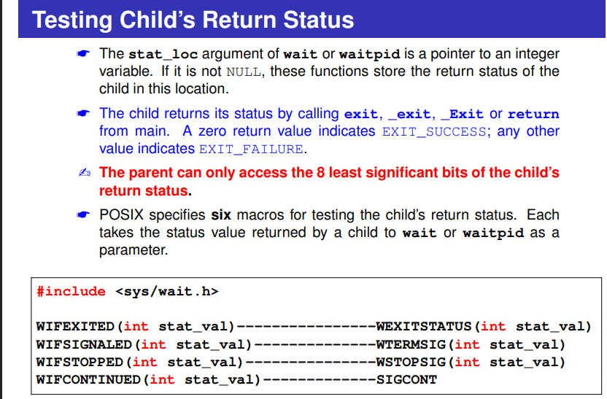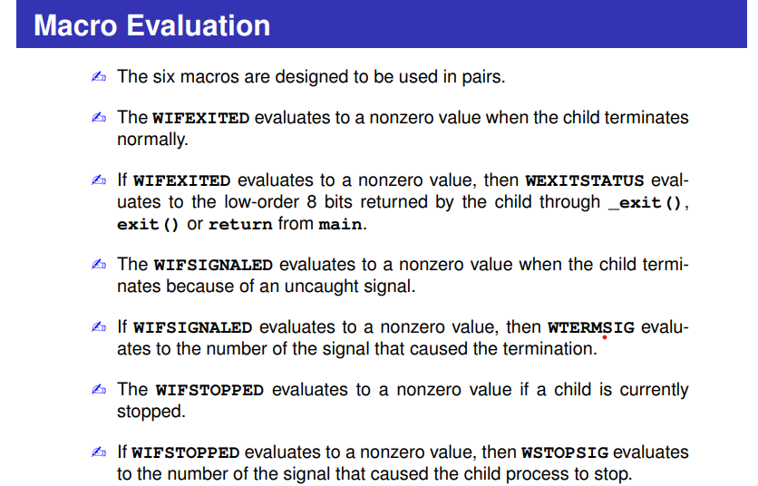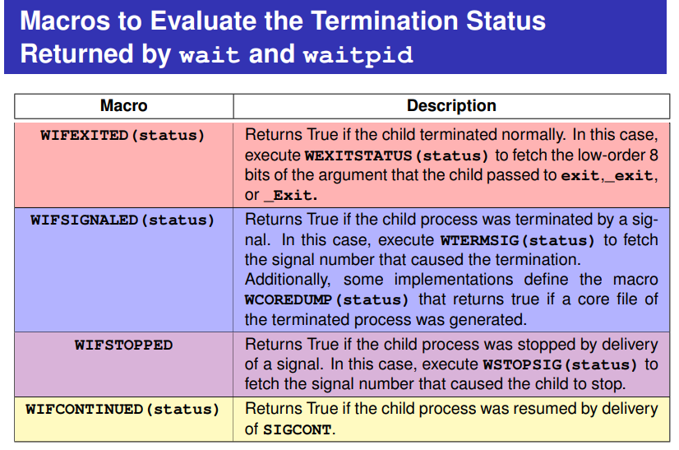

Child exits normally (exit(0))
#include <stdio.h>
#include <unistd.h>
#include <stdlib.h>
#include <sys/wait.h>

int main() {
pid_t pid = fork();
int status;

if (pid == 0) {
printf("Child: normal exit\n");
exit(0); // success exit
}

wait(&status);

if (WIFEXITED(status) && WEXITSTATUS(status) == 0)
printf("Parent: child exited normally with status 0\n");

return 0;
}

Child exits with non-zero status (exit(5))
#include <stdio.h>
#include <unistd.h>
#include <stdlib.h>
#include <sys/wait.h>

int main() {
pid_t pid = fork();
int status;

if (pid == 0) {
printf("Child: exiting with error code 5\n");
exit(5); // non-zero exit
}

wait(&status);

if (WIFEXITED(status))
printf("Parent: child exited with status %d\n", WEXITSTATUS(status));

return 0;
}

Child terminated by signal (e.g., SIGKILL or SIGSEGV)

Example A: Force segmentation fault
(Easy to test without root permissions)
#include <stdio.h>
#include <unistd.h>
#include <stdlib.h>
#include <sys/wait.h>

int main() {
pid_t pid = fork();
int status;

if (pid == 0) {
printf("Child: causing segmentation fault\n");
int *p = NULL;
*p = 10; // SIGSEGV
//This dereferences a null pointer → Segmentation Fault (SIGSEGV). Int a=8/0;
}

wait(&status);

if (WIFSIGNALED(status))
printf("Parent: child terminated by signal %d\n", WTERMSIG(status));

return 0;
}

o/p:--
Child: causing segmentation fault
Parent: child terminated by signal 11 (The OS kills it with signal 11 (SIGSEGV).)

Child: causing segmentation fault
Parent: child terminated by signal 8

SIGSEGV, or a segmentation fault, is a signal sent to a process by a Unix-based operating system when it attempts to access memory it does not have permission to access.

Unix, signal 8 is the SIGFPE signal, which stands for Floating-point exception. (8/0)

Example B: Parent kills child using SIGKILL
(Optional)
#include <stdio.h>
#include <unistd.h>
#include <stdlib.h>
#include <signal.h>
#include <sys/wait.h>

int main() {
pid_t pid = fork();
int status;

if (pid == 0) {
printf("Child: waiting to be killed\n");
sleep(10);
}

sleep(1);
kill(pid, SIGKILL); // parent kills child

wait(&status);

if (WIFSIGNALED(status))
printf("Parent: child was killed by signal %d\n", WTERMSIG(status));

return 0;
}
o/p—
Child: waiting to be killed
Parent: child was killed by signal 9
SIGKILL, or signal number 9: Unix/Linux signal used to immediately and forcefully terminate a process without giving it a chance to perform any cleanup

Child stopped by signal (SIGSTOP)
#include <stdio.h>
#include <unistd.h>
#include <stdlib.h>
#include <signal.h>
#include <sys/wait.h>

int main() {
pid_t pid = fork();
int status;

if (pid == 0) {
printf("Child: running... will be stopped by parent\n");
while (1); // run forever
}

sleep(1);
kill(pid, SIGSTOP); // parent sends STOP signal

waitpid(pid, &status, WUNTRACED); // must use WUNTRACED!

if (WIFSTOPPED(status))
printf("Parent: child stopped by signal %d\n", WSTOPSIG(status));

kill(pid, SIGKILL); // cleanup
wait(NULL);

return 0;
}
o/p—
Child: running... will be stopped by parent
Parent: child stopped by signal 19
Example 5:
#include<stdio.h>
#include<unistd.h>
#include<stdlib.h>
#include<sys/wait.h>
int main(void){
pid_t childpid,pid;
int status;
pid=fork();
if(pid==0){
printf("Child Part Executed!!!!\n");
exit(0);
}
else{
childpid=wait(&status);
if (childpid == -1)
perror("Failed to wait for child\n");
else if (WIFEXITED(status) && !WEXITSTATUS(status))
printf("Child %ld terminated normally\n", (long)childpid);
else if (WIFEXITED(status))
printf("Child %ld terminated with return status %d\n",(long)childpid, WEXITSTATUS(status));
else if (WIFSIGNALED(status))
printf("Child %ld terminated due to uncaught signal %d\n",(long) childpid, WTERMSIG(status));
else if (WIFSTOPPED(status))
printf("Child %ld stopped due to signal %d\n",(long)childpid, WSTOPSIG(status));
}
return 0;}

The waitpid Function
✍ The waitpid function takes three parameters:
✍ a pid,
✍ a pointer to a location for returning the status
✍ a flag specifying options.
✍ waitpid synopsis

#include <sys/wait.h>
pid_t waitpid(pid_t pid, int *stat_loc, int options);

✍ If waitpid returns because the status of a child is reported, these functions return the process ID of that child.
✍ If an error occurs, these functions return -1 and set errno.
First parameter==Pid_t pid
✍ If pid = −1, waitpid waits for any child. In this respect, waitpid is equivalent to wait.
✍ If pid > 0, waitpid waits for the child whose process ID equals pid.
✍ If pid = 0, waitpid waits for any child whose process group ID equals that of the calling process.
✍ If pid < −1, waitpid waits for any child whose process group ID equals the absolute value of pid.
Second parameter== int *stat_loc
✍ The stat_loc argument of wait or waitpid is a pointer to an integer variable based on exit.
✍ If it is not NULL, these functions store the return status (access the 8 least significant bits) of the child in this location.
Third parameter== int options

✍The options parameter is either zero or is constructed from the bitwise OR of the constants: WNOHANG, WUNTRACED, and WCONTINUED
✍ The options = 0 :: The waitpid waits until the child change state.
✍ The option WNOHANG :: The waitpid will not block if a child specified by pid is not immediately available. In this case, the return value is 0.
☞ The option WUNTRACED :: The waitpid to report the status of unreported child processes that have been stopped. The WIFSTOPPED macro determines whether the return value corresponds to a stopped child process. ☞ The WCONTINUED :: The waitpid returns if a stopped child has been resumed by delivery of the signal SIGCONT

Example:
wait(NULL) or waitpid(-1, NULL, 0);

int status;
wait(&status) or waitpid(-1, &status, 0);
Example1:

#include<stdio.h>
#include<sys/ wait.h>
#include<unistd.h>
#include<stdlib.h>
int main(){
pid_t p1=fork();
if(p1==0){
printf("child p1 PID %d \n", getpid());
sleep(5);
printf("p1 emitted \n");
return 0;
}
pid_t p2=fork();
if(p2==0){
printf("child p2 PID %d \n", getpid());
sleep(3);
printf("p2 emitted \n");
return 0;
}
pid_t w_pid1=waitpid(p1, NULL, 0);
pid_t w_pid2=waitpid(p2, NULL, 0);
if(w_pid1==-1 || w_pid2==-1){
exit(0);
}
if(w_pid1>0){printf("w_pid1 %d \n", w_pid1);
}
if(w_pid2>0){printf("w_pid2 %d", w_pid2);
}
}

//output
child p1 PID 11291
child p2 PID 11292
p2 emitted
p1 emitted
w_pid1 11291
w_pid2 11292

Example 2
#include<stdio.h>
#include<stdlib.h>
#include<sys/wait.h>
#include<unistd.h>

void waitexample()
{
int i, stat;
pid_t pid[5];
for (i=0; i<5; i++)
{
if ((pid[i] = fork()) == 0)
{
sleep(1);
exit(100 + i);
}
}

// Using waitpid() and printing exit status
// of children.
for (i=0; i<5; i++)
{
pid_t cpid = waitpid(pid[i], &stat, 0);
if (WIFEXITED(stat))
printf("Child %d terminated with status: %d\n", cpid, WEXITSTATUS(stat));
}
}

// Driver code
int main()
{
waitexample();
return 0;
}
//output
Child 9562 terminated with status: 100
Child 9563 terminated with status: 101
Child 9564 terminated with status: 102
Child 9565 terminated with status: 103
Child 9566 terminated with status: 104

Example 3:
#include <stdio.h>
#include <stdlib.h>
#include <unistd.h>
#include <sys/wait.h>
#include <signal.h>
void print_status(int status) {
if (WIFEXITED(status)) {
printf("Child exited normally. Exit code = %d\n", WEXITSTATUS(status));
}
if (WIFSIGNALED(status)) {
printf("Child was terminated by signal %d\n", WTERMSIG(status));
}
if (WIFSTOPPED(status)) {
printf("Child was stopped by signal %d\n", WSTOPSIG(status));
}
if (WIFCONTINUED(status)) {
printf("Child continued due to SIGCONT\n");
}
}

int main() {
pid_t child1, child2, child3;
int status;

printf("=== TESTING waitpid() ===\n");

// ---------- CHILD 1: Exits normally ----------
child1 = fork();
if (child1 == 0) {
sleep(2);
exit(10);
}

// ---------- CHILD 2: Will be stopped ----------
child2 = fork();
if (child2 == 0) {
printf("Child2 running.. sending SIGSTOP to itself.\n");
raise(SIGSTOP); // Stop itself
exit(20);
}

// ---------- CHILD 3: Will be stopped and continued ----------
child3 = fork();
if (child3 == 0) {
printf("Child3 running.. sending SIGSTOP to itself.\n");
raise(SIGSTOP);
sleep(2);
exit(30);
}

sleep(1); // Give children time

// ----------- TEST 1: pid = -1 (wait for ANY CHILD) ----------
printf("\n[TEST 1] pid = -1 (wait for ANY child)\n");
pid_t r1 = waitpid(-1, &status, WNOHANG | WUNTRACED | WCONTINUED);
printf("waitpid(-1) returned PID = %d\n", r1);
print_status(status);

// ----------- TEST 2: pid > 0 (specific child) ----------
printf("\n[TEST 2] pid = child1 (%d) -- waiting for normal exit\n", child1);
pid_t r2 = waitpid(child1, &status, 0);
printf("waitpid(child1) returned PID = %d\n", r2);
print_status(status);

// ----------- TEST 3: pid = 0 (same process group) ----------
printf("\n[TEST 3] pid = 0 (any child in same process group)\n");
pid_t r3 = waitpid(0, &status, WUNTRACED);
printf("waitpid(0) returned PID = %d\n", r3);
print_status(status);

// Continue child3
printf("\nSending SIGCONT to child3 (%d)\n", child3);
kill(child3, SIGCONT);

// ----------- TEST 4: pid < -1 (wait for process group -pgid) ----------
printf("\n[TEST 4] pid = -%d (wait for process group)\n", getpgrp());
pid_t r4 = waitpid(-getpgrp(), &status, WCONTINUED);
printf("waitpid(-pgid) returned PID = %d\n", r4);
print_status(status);

// Final wait to clean remaining child
while (wait(NULL) > 0);

printf("\n=== DONE ===\n");
return 0;
}
o/p:

=== TESTING waitpid() ===
Child2 running.. sending SIGSTOP to itself.
Child3 running.. sending SIGSTOP to itself.

[TEST 1] pid = -1 (wait for ANY child)
waitpid(-1) returned PID = 318751
Child was stopped by signal 19

[TEST 2] pid = child1 (318750) -- waiting for normal exit
waitpid(child1) returned PID = 318750
Child exited normally. Exit code = 10

[TEST 3] pid = 0 (any child in same process group)
waitpid(0) returned PID = 318752
Child was stopped by signal 19

Sending SIGCONT to child3 (318752)

[TEST 4] pid = -318746 (wait for process group)
waitpid(-pgid) returned PID = 318752
Child continued due to SIGCONT

Feature | wait() | waitpid()

Waits for which child? | Any child | Specific child or group

Can detect stopped child? | ❌ NO | ✔ YES (with WUNTRACED)

Can avoid blocking? | ❌ NO | ✔ YES (with WNOHANG)

Can return on continued child? | ❌ NO | ✔ YES (with WCONTINUED)

More control? | ❌ Less control | ✔ More control

Exec
The exec family of functions replaces the current process image with a new process image.
The exec operation replaces the entire address space(text, data, and stack) with that of the new process.
Since the stack is also replaced, the call to exec family of functions donot return unless it results in an error.
To actually run a new command (like ls -l, ps, cat file.txt) in the child process created by fork() must call exec().
The child executes (with an exec function) the new program while the parent continues to execute the original code.
All exec functions return -1 and set errno if unsuccessful.
If any of these functions return at all, the call was unsuccessful.

Execv--Arguments passed as an array of strings (vector version)
Execl--Arguments passed as separate parameters (variable-length list)
• execl → list version, no PATH search, no custom environment.
• execlp → list version, searches PATH, no custom environment.
• execle → list version, full path, allows custom environment.

✍ The exec: l series: l - a fixed list of arguments
✍ execl(argument list)
✍ execle(argument list)
✍ execlp(argument list
✍ The exec: v series: v - a variable number of arguments
✍ execv(argument list)
✍ execve(argument list)
✍ execvp(argument list)

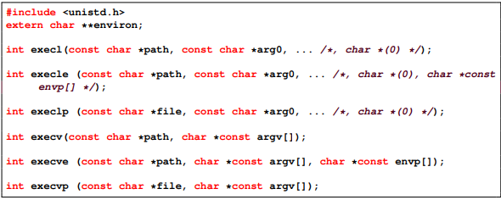

✍ The execl (execl, execlp and execle) functions pass the commandline arguments in an explicit list and are useful if the number of commandline arguments are known at compile time.
✍ The execv (execv, execvp and execve) functions pass the commandline arguments in an argument array.
✍ The argi parameter represents a pointer to a string.
✍ argv and envp represent NULL-terminated arrays of pointers to strings.
✍ The path parameter to execl is the pathname of a process image file specified either as a fully qualified pathname or relative to the current directory.
✍ The individual command-line arguments are then listed, followed by a (char ∗) 0 pointer (a NULL pointer).

Execl
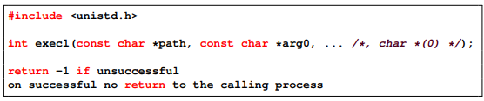
// execl

Example 1:
#include<stdio.h>
#include<unistd.h>
int main()
{
char *bin_path="/bin/ls";
char *arg1="-a";
char *arg2="-s";
execl(bin_path, bin_path, arg1, arg2, NULL);
return 0;
}
Example 2:
#include<stdio.h>
#include<unistd.h>
int main(void){
pid_t childpid;
childpid=fork();
if (childpid ==-1) {
perror("Failed to fork");
return 1;
}
if (childpid ==0){ /* childcode */
execl("/bin/ls", "ls","-l", NULL);
perror("Child failed to execls");
return 1;
}
if (childpid !=wait(NULL)) { /* parentcode */
perror("Parentfailed to waitduetosignalorerror");
return 1;
}
return0;
}

//execlp (file name, file name, argument, argument)
Example 1:
#include<stdio.h>
#include<unistd.h>
int main()
{
char *bin_path="ls";
char *arg1="-a";
char *arg2="-s";
execlp(bin_path, bin_path, arg1, arg2, NULL);
return 0;
}
o/p—
total 24
0 . 4 .. 16 a.out 4 main.c

Example 2:
#include<stdio.h>
#include<stdlib.h>
#include<unistd.h>
int main(void)
{
char *temp1,*temp2;
temp1="Funny"; temp2="world";
pid_t pid;
pid=fork();
if(pid==0){
execlp("echo","echo",temp1,temp2,NULL);
printf("Error");
return 1;
}
else{
/* Parent code*/
}
return 0;
}
o/p- Funny world
//execle
Example 1:
#include <stdio.h>
#include <unistd.h>
int main()
{
// FULL PATH REQUIRED for execle (it does NOT search PATH)
char *bin_path = "/bin/ls";

char *arg1 = "-a";
char *arg2 = "-s";

// Custom environment array (must end with NULL)
char *envp[] = {
"MYVAR=123",
NULL
};
execle(bin_path, "ls", arg1, arg2, NULL, envp);
return 0;
}
Example 2:
#include<stdio.h>
#include<stdlib.h>
#include<unistd.h>
int main(void)
{
int err;
err=execle("/usr/bin/wc","wc","execldemo.c",NULL,NULL);
if(err==-1){
perror("Execle Failed\n");
}
return 0;
}
Execv
✍ The execv function takes exactly two parameters, a pathname for the executable and an argument array.
✍ Used to run a command or executable with any number of arguments.
✍ Use an execv function with an argument array constructed at run time.
✍ The execve and execvp are variations on execv; they are similar in structure to execle and execlp, respectively.
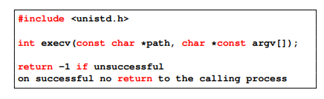
Example:
#include<stdio.h>
#include<stdlib.h>
#include<unistd.h>
#include<sys/wait.h>
int main(void)
{
char *cmdargs[]={"ls", "-l", NULL};
pid_t pid;
pid=fork();
if(pid==0){
execv("/bin/ls",cmdargs);
}
else{
wait(NULL);
printf("child terminate\n");
}
return 0;
}
o/p:
total 20
-rwxr-xr-x 1 runner18 runner18 16080 Nov 30 09:30 a.out
-rw-r--r-- 1 runner18 runner18 609 Nov 30 09:30 main.c
child terminate
Example:
#include<stdio.h>
#include<stdlib.h>
#include<unistd.h>
#include<sys/wait.h>
int main(int argc, char *argv[])
{
int i;
char *cmdarg[20];
for(i=1;argv[i]!=NULL;i++){
cmdarg[i-1]=argv[i];
}
cmdarg[i-1]=NULL;
execv("/bin/ls",cmdarg);
return 0;
}
o/p—

a.out main.c
Example 3:
Example.c
#include<stdio.h>
#include<stdlib.h>
#include<unistd.h>
int main(int argc, char *argv[])
{
printf("PID of example.c %d\n",getpid());
char *args[]={"Hello", "c", 'Programming", "NULL"};
execv("./hello", args);
printf("Back to example.c");
return 0;
}
Hello.c
#include<stdio.h>
#include<stdlib.h>
#include<unistd.h>
int main(int argc, char *argv[])
{
printf("In hello.c");
printf("PID of hello.c %d\n",getpid());
return 0;
}

----
gcc example.c –o example
gcc hello.c –o hello
./example

o/p
PID of example.c =2428
In hello.c
PID of hello.c=2428

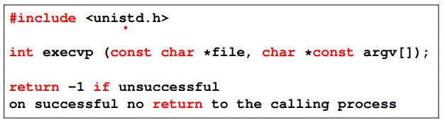

#include<stdio.h>
#include<stdlib.h>
#include<unistd.h>
#include<sys/wait.h>
int main(void)
{
char *cmdargs[]={"ls", "-l", NULL};
pid_t pid;
pid=fork();
if(pid==0){
execvp("ls",cmdargs);
}
else{
wait(NULL);
printf("chile terminate\n");
}
return 0;
}
o/p:-
total 20
-rwxr-xr-x 1 runner67 runner67 16088 Dec 5 13:57 a.out
-rw-r--r-- 1 runner67 runner67 268 Dec 5 13:57 main.c
chile terminate
Example 2:
#include<stdio.h>
#include<stdlib.h>
#include<unistd.h>
#include<sys/wait.h>
int main(int argc, char *argv[])
{
pid_t pid;
pid=fork();
if(pid==0){
execvp("ls",&argv[1]);
}
else{
wait(NULL);
printf("chile terminate\n");
}
return 0;
}
o/p:
a.out main.c
chile terminate
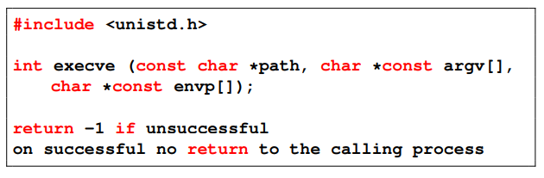
#include<stdio.h>
#include<stdlib.h>
#include<unistd.h>
#include<sys/wait.h>
int main(void)
{
char *cmdargs[]={"ls", "-l", NULL};
pid_t pid;
pid=fork();
if(pid==0){
execve("/bin/ls", cmdargs, NULL);
}
else{
wait(NULL);
printf("chile terminate\n");
}
return 0;
}
o/p:
total 20
-rwxr-xr-x 1 runner82 runner82 16088 Dec 5 13:52 a.out
-rw-r--r-- 1 runner82 runner82 280 Dec 5 13:52 main.c
chile terminate

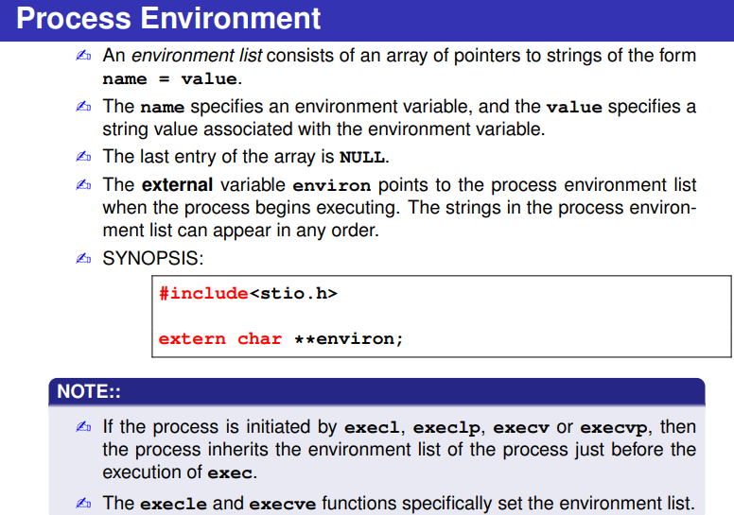#include <stdio.h>
#include <unistd.h>
extern char **environ;
int main(void) {
int i;
printf("The environment list follows:\n");
for(i = 0; environ[i] != NULL; i++){
sleep(2);
printf("environ[%d]: %s\n", i, environ[i]);
}
return 0;
}
o/p:
The environment list follows:
environ[0]: LIBRARY_PATH=/nix/store/j996abv6lbdhfbaar2964kyx2q87i2vx-env/lib:
environ[1]: LANGUAGE=en_US:en
environ[2]: NODE_VERSION=v20.16.0
environ[3]: HOSTNAME=Check
environ[4]: SHLVL=1

